This zips all files and directories

-r: Includes all files and directories -> Files

filename.zip: The zip file you want to create

foldername The folder you are targeting or use * if your currently in the folder

**zip -r filename.zip foldername**

What Is PuTTy?

Simply put:

[PuTTy](http://www.chiark.greenend.org.uk/~sgtatham/putty/download.html) is an open source [SSH client](https://en.wikipedia.org/wiki/Comparison_of_SSH_clients) used to connect to a remote server.

It’s basically a terminal emulator for Windows based operating systems.

*A terminal emulator? What is that?*

To understand this you must first understand how Linux servers work.

Say you have a server set up.

Now:

To connect to your server from your PC you can use PuTTy and type simple SSH commands to perform different basic actions such as creating folders, copying them and so on.

Linux already has a terminal.

So if you are running Linux as your desktop OS you don’t need a ssh client because you can use the already build in terminal.

### **Basic Navigation**

**1.) How to find out where you are**

pwd

Type **pwd** to see where on the server you are.

For example if I type **pwd** in PuTTy it returns **/root**

example of PuTTy command

**2.) Navigate to…**

cd

The **cd** command (also known change directory) is used to navigate into a specified directory on your server.

Such as:

cd /home (moves you into the home folder)

Example:

home folder SSH command

or

Say I want to navigate to the /etc directory. All I have to do is type cd /etc.

Example:

etc folder

**3.) The same directory**

cd .

The **cd .** command does basically nothing. Using this command you will remain in the same directory you were.

same directory

**4.) Move me up one directory**

cd ..

Remember the previous command? Well I included it for a reason!

Add another dot(stop) to **cd .** and you will end up with **cd ..** which will move you up one directory.

up one directory

**5.) Go to the previous directory**

cd –

The **cd –** command is used when you want to go to the previous directory.

previous directory

**6.) Go to Home folder**

cd ~

The **cd ~** commands is used when you want to go to the home directory on your server.

**7.) Go to root**

cd /

The **cd /** command is used when you want to jump to root.

### **List Directories and Contents**

**8.) List files**

ls

usage: **ls [option] [file]**

Using [the ls command](https://en.wikipedia.org/wiki/Ls) in a folder will display all it’s content.

Such as: ls /home.

Will return all content of the folder /home.

**9.) Show me all files in a directory**

ls -a

list files

**10.) Show contents with file size**

ls -h

If you wish to see a directory’s contents with file sizes just type **ls -h**

**11.) How to list sub-directories recursively**

ls -r

The **ls -r** command is used to list sub-directories recursively.

**12.) How to list files by file size**

ls -is

Use this ssh command to list files by size.

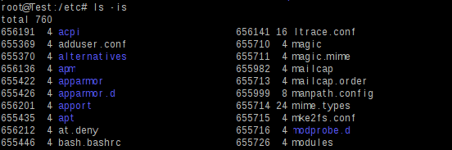

**13.) List all folders in directory with details**

ls -alh

This one is very useful when you want to see more details about certain files.

For example you may want to know file permissions of a directory.

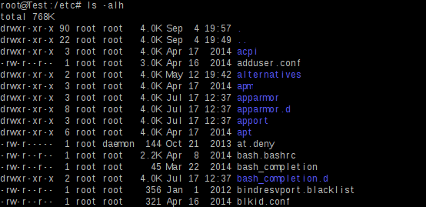

### **Copying files**

**14.) Copying a file**

cp

To copy a file just use the cp ssh command.

Example:

cp filename.php /home/filename.php

**15.) Copy a folder with all files**

cp -r

This one is used to copy the entire folder with all it’s contents.

**16.) Copy and rename**

cp filename.php /home/filename2.php

copy and rename

### **Moving files**

**17.) Moving a file**

mv

Example:

mv page.php /home/page.php

**18.) Move and rename**

mv page.php /home/newpage.php

move file

**19.) Move file up one directory**

mv filename ..

example: mv index.html/ ..

### **Creating files/folders**

**20.) Create a folder**

mkdir

example: mkdir new-folder

create a folder

**21.) Create a file**

touch

Use the touch command to create different files and file extensions (you can later edit them)

Example:

touch index.php

touch index.html

touch robots.txt

create index.html

### **Compressing/Decompressing files**

**22.) Compressing folders**

zip -r foldername.zip foldername

Example:

zip -r newfolder.zip newfolder

zip command in putty

**23.) Decompressing folders**

unzip

Example:

unzip newfolder.zip

unzip command

**24.) Compressing folders using tar -czvf**

tar -czvf foldername.tar.gz foldername

Example:

tar -czvf wp-content.tar.gz wp-content

**25.) Decompressing folders using tar -czvf**

tar -xvf foldername.tar.gz

Example:

tar -xvf wp-content.tar.gz

### **Delete/Remove files**

**26.) Delete a file**

rm

To delete a file on your server just use the **rm** command.

Example:

rm index.php

delete a file

**27.) Delete all files from a directory**

rm *

This command is used to delete all contents from a directory.

Example:

rm * foldername

**28.) Delete a folder/directory**

rmdir

Use this command to remove directories.

Here’s how: rmdir foldername

delete directory

### **File permissions**

**29.) Change file permissions**

chmod

Example:

chmod 775 newfolder

chmod command

**30.) Change permissions of folder and all files inside**

chmod -r

This command comes in handy when you want to change file permissions of an entire folder including it’s contents.

### **Miscellaneous**

**31.) Memory usage**

free -m

Great command to monitor memory usage!

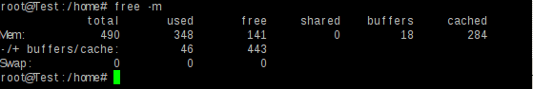

**32.) What user am I?**

whoami

If you don’t know what user your are just use **whoami**

check user

**33.) Show network connections**

netstat

Displays current networks connections

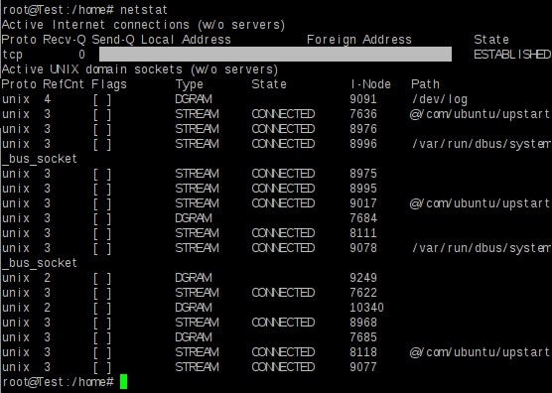

**34.) Monitor CPU, processes and memory**

top

Type to to monitor CPU usage, processes and RAM.

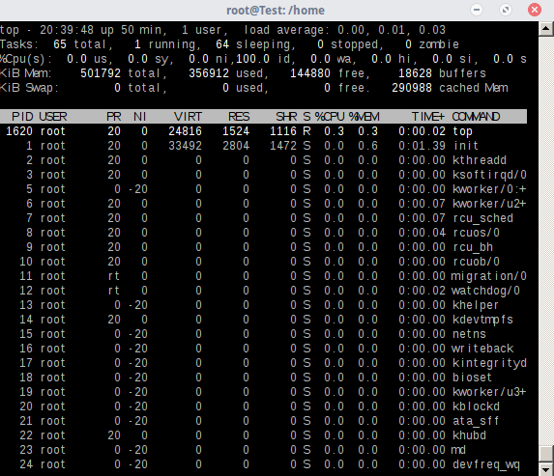

**35.) Display sever disk usage**

df -h

If you want to see how much disk is used on your server just type **df -h**